Write a PL/SQL procedure to display the salesman id,name,city and commission of the salesman with id as 5007.

Q. Write a procedure to display employee_id, manager,job of employees whose last_name is 'King'.

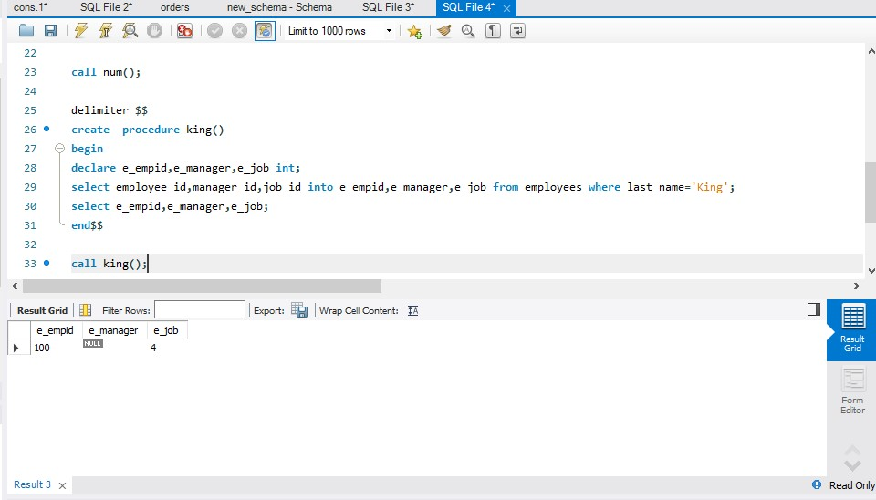

Q Write a procedure to display department number ,department_name whose location id is 1800.

